**what is php ?**

php is a server side scripting language.

Php first time release in 1994 by rasmas landroef.

Php stands for in 1994 personal home page.

Php furthure updated in 1996 and stands for php:hypertext preprocessor.

Php support all database

Eg: mysql , sqllite, sqlserver, oracle, mongodb ,.

Php is a open source language.

Eg: php , java , android , react js etc.

Php support all operating systems

Eg: windows family, ubuntu , macc etc.

Php support all server

Eg: apache, iis , tomcat etc.

Php is a loosly typed of language.

Eg: $name=”brijesh”;

$a=54545;

Note : we defined any variables but ot need to identify data type of variable so its called loosly type of language.

Php is used to make a dynamic website or web applications.

Ex: flipkart | facebook | instagrame | all mobile appications api | shopclues | Wikipedia | pinteterst etc.

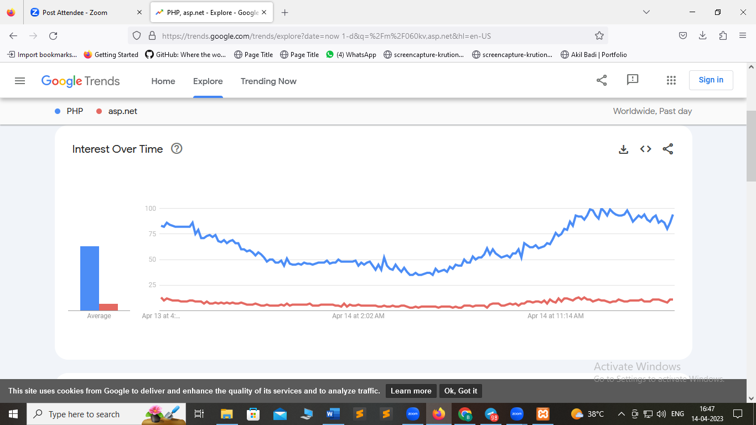

XAMPP | WAMP | LAMP

This is a server tools where we run php

X =>cross plateform (support for all OS)

A=>apache

M=>mysql

P=>perl (procedural based language)

P=>php

W =>windows family.

A=>apache

M=>mysql

P=>php

L =>Linux/Unix

A=>apache

M=>mysql

P=>php

Port default of apche : 80

<http://localhost/php4mwf/module3/corephp4/php-structure-delemeters/name.php>

Change port with 81

<http://localhost:81/php4mwf/module3/corephp4/php-structure-delemeters/name.php>

Delemeters of php

<?=

// direct output single values delimeters

$name="hello jeet";

$name1="hello kavita";

$name2="hello mintu";

?>

<?php

// standard delimeters

$name="hello mansi";

$name1="hello jeet";

$name2="hello raghav";

echo $name."<br>".$name1."<br>".$name2;

?>

Php file extentions is .php | .php3 | .phtml

Php is a server side scripting language.

Php stands for php:hypertext preprocessor

Note :